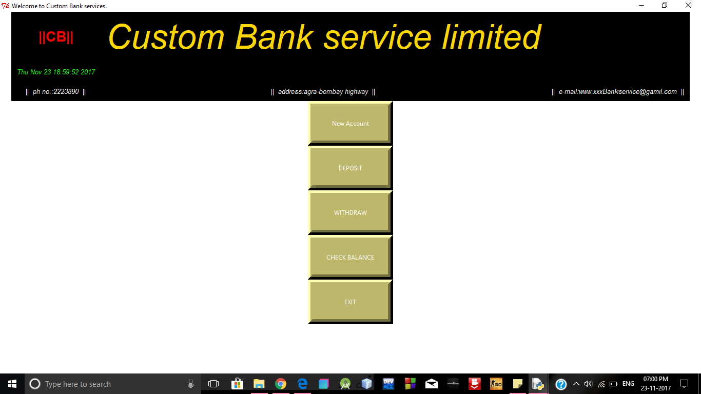
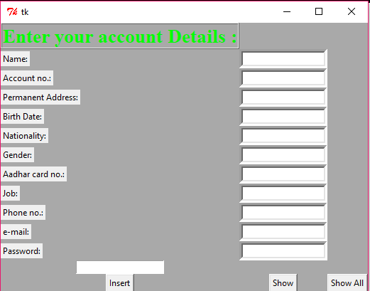
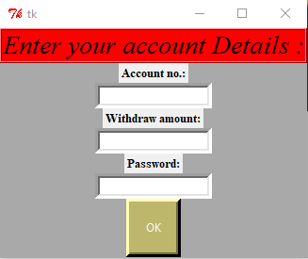
Name : Utkarsh Singh .
Enrollment no.: 161B257 .
Batch : B-9 .
Branch : Computer Science Engineering .
Course : B-TECH .
E-mail : utkarshsingh5298291@gmail.com .
Submitted to: Dr . Mahesh Kumar .

About the Project: Banking System
…………………………………………………………………
Nowdays,the world is getting advanced ,faster,inovative and full of technology.No one likes to waste his/her time.People are getting switching to e-commerce websites for shoping rather than visiting the local shops,there are two reasons for this one is saving time and other is things get easy and simplified.So,i choose to make online banking system seeing relationship with e-commerce.My father is also an officer in the Union Bank of India,an Indian government firm.

1.)My project is on banking system .With this basically , we can make user’s fill the form of bank and enter his detail’s in the form to open new account.
You can see the home page of the Tkinter .
2.)Now , you can see the Tkinter that opens up after clicking on the 1st button i.e. New Account.User can fill form which gets saved in the database,so that the information of user is stored for next time when he tries to log into his account .After filling the form he needs to insert the data by clicking on the button 'Insert'.To see all the accounts you can click on 'show all' button.
3.)Now , the Tkinter that opens up after clicking on the 2nd button of the home page i.e. Deposit.You can enter the deposit amont and it will get saved.Simmilarly, Tkinter that opens up after clicking on the 3rd button of the home page i.e. Withdraw.
4.)There is a checkbalance button ,by clicking on it you can check your balance.
5.)There is an exit button that brings you out or closes the application.

